**SCRIPT**

**DOCUMENTARY #2**

**THIS IS CATHOLIC COURAGE:**

**The Traditional Tridentine Holy Sacrifice of the Mass**

**Celebrated in Latin**

**- Dedicated to Saint Joseph -**

**Michele Bondi Bottesi**

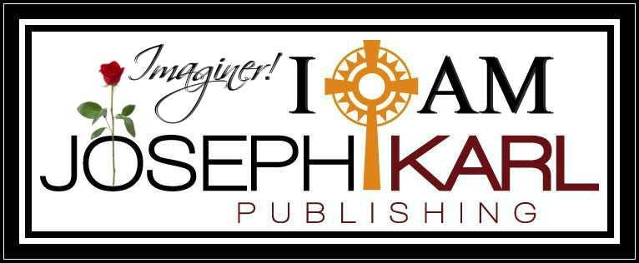

**SCRIPT**

**THIS IS CATHOLIC COURAGE:**

**THE MAJESTIC TRADITIONAL TRIDENTINE**

**HOLY SACRIFICE OF THE MASS CELEBRATED IN LATIN**

**C O N T E N T S**

**INTRODUCTION**

Love Divine

**CHAPTER I**

Feel the Zeal!

**CHAPTER II**

The Majestic Traditional Tridentine Holy Sacrifice of the Mass

Celebrated in Latin and Sacramental Reconciliation

**CHAPTER III**

What the Majestic Traditional Tridentine Holy Sacrifice of the Mass

Celebrated in Latin Is

**CHAPTER IV**

The Majestic Traditional Tridentine Holy Sacrifice of the Mass Celebrated in Latin

and The Work of Reparation to the Holy Face of Jesus

**CONCLUSION**

**INTRODUCTION**

**LOVE DIVINE**

*"Whatever else the Mass is, it is meant by Christ to be a prayer,*

*in fact, the most sublime prayer that a creature can make to the Creator*

*and the one most pleasing to God."*

*~ Fr. John A. Hardon, S.J., "Praying the Mass"*

**CHAPTER I**

**CHAPTER II**

**SACRAMENTAL RECONCILIATION AND**

**THE MAJESTIC TRADITIONAL TRIDENTINE**

**HOLY SACRIFICE OF THE MASS CELEBRATED IN LATIN**

**A RECONCILIATION PRAYER FOR EVERY SOUL**

Oh sweet Author of Life,

Your pardon I seek as I kneel before Your Cross.

Lord, forgive me.  
  
Immerse me in Your compassion,

for I have so little to offer you.

Even my petition for forgiveness comes from You.  
  
You long for my approach though wounded,

so generously willing to exchange human iniquity

with Your Love that immolates and saves,

when the soul but accepts Your invitation.  
   
I give my nothingness entirely to You.  
   
Divine Justice have mercy on me

and may all my brothers and sisters benefit also,  
especially those most in need

of Your sanctifying and eternally saving Divine grace.  
  
Blood of Christ wash over me

and transform me into Your likeness.

Make of me the mirror that reflects Your love to Your beloved.  
  
Thank You for Your sacrifice and invitation,

and for Your patience while awaiting my response,  
as I seek Your will while You encourage me

to make proper use of my free will.   
  
Thank You for lovingly creating, teaching,

guiding, and consoling me,

and for all You have generously given me  
including the grace to recognize that

which on my own I cannot see.  
  
Thank You for allowing me to lose that I may win

and for giving me the opportunity to journey with You

along Your Way of the Cross.  
  
I accept Your love,

and return to You my heart united with Yours,

along with my obedience.  
  
Jesus, thank You for everything, God’s will be done;

please accept my petition to fill this dry well

with Your Divine Presence.  
  
Amen.

**CHAPTER III**

**WHAT THE MAJESTIC CATHOLIC**

**TRADITIONAL TRIDENTINE HOLY SACRIFICE OF THE MASS**

**CELEBRATED IN LATIN IS**

The Traditional Tridentine Holy Sacrifice of the Mass is the liturgy in the Roman Missal of the Catholic Church codified in 1570 and published thereafter with amendments up to 1962. The Traditional Latin Mass is the venerable Mass that could be found all over the world, and was celebrated in no other form, from 1564 until 1962.

It is a magnificent and sacred love story that transcends time and place.

It is a conversation by deeds and self-surrender to God via the free will.

It is bi and tri location, every souls wedding, and a journey through mankind’s past, present, and future.

It is the highest form of Eucharistic Adoration.

It is an appreciation for silence and for what is right and just.

It is a surrender, it is prayer, petition, and Divine Union.

It is understanding, and an act of the free will.

It is the Divine Remedy against corruption.

It is an appeal for all souls, including all of one's brothers and sisters in Christ (meaning all people past, present, and future) and also one's own poor soul.

It is a Wedding, the Royal Wedding of each properly disposed soul to Jesus Christ the Divine Bridegroom and our Divine Redeemer, Divine Restorer, and Divine Remedy for All.

It is a betrothal, a wedding, and a reception all in one.

It is a wedding, the honeymoon, Divine Union, and creation inside of God's House. 

It is beautiful, beautiful, beautiful, beautiful.

It is understanding, planning, attending, and sharing.

It is a foretaste of heaven.

It is a sacrifice two-ways: Christ’s sacrifice of Himself for us and our sacrifice of ourselves for Him.

It is for the greater honor and glory of our Triune God, and then for the sake of all souls through all time including one’s own poor soul.

Truly no banquet hall could be finer, no structure more indestructible, no royal reception more lavish, no gold put to more appropriate use.

No candles could burn brighter, no linens could be more sacred, no Father more generous, no Mother more caring, no Groom more loving, no guests more grateful to be there.

No celebration could be more pure, no attendants more genuine, no sacred vows more important, no effects longer lasting, no apostolic mission of more importance, no garments more regal, no singing more beautiful, no silence more expressive, no humble and properly disposed leaders better suited to lead.

No children could be more blessed, no expressions could be more royal, no gifts more valuable, no event more meaningful, no gratitude more overflowing, and no memories more cherished.

*"Even if Catholics faithful to Traditional are reduced to a handful, they are the one who are the True Church of Jesus Christ." ~ Saint Athanasius*

**CHAPTER IV**

THE MAJESTIC TRADITIONAL TRIDENTINE HOLY SACRIFICE OF THE MASS

CELEBRATED IN LATIN AND

THE WORK OF REPARATION TO THE HOLY FACE OF JESUS

**CONCLUSION**